Statement of Work

Version 0.1
March 8, 2023
Contents
1 Statement of Work 3
1.1 Summary 3
1.2 High level solution architecture 3
1.3 References 5
1.4 Project Objectives 5
1.5 Responsibilities 6
1.6 Project Administration 7
2 Exclusions & Limitations 8
3 Cost and Resourcing 9
3.1 Salesforce Licese Fees 9
3.2 Implementation Costs 9
3.3 6 month support transition plan 12
4 Project Delivery Methodology 13
4.1 Requirement Analysis & Project Backlog Creation 13
4.2 Sprint planning 13
4.3 Sprint 14
4.4 Sprint UAT 14
4.5 End-to-End UAT 14
4.6 Go-Live and Support 15
5 Acceptance 16

Statement of Work

Summary
has an existing Lead to Lease process implemented within their Salesforce org. Included in this process, there is an existing point-to-point API integration between Salesforce and RightMove that facilitates the lease referencing process. have taken the decision to move to the HomeLet lease referencing service instead of RightMove and need to make various changes to the relevant integrations.
The following Statement of Work (SOW) describes the development work required to update Grainger PLC’s Salesforce org to integrate to the HomeLet lease referencing service.

existing salesforce integrations

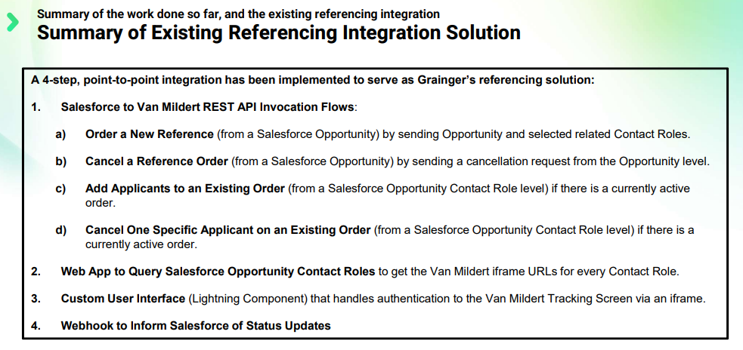

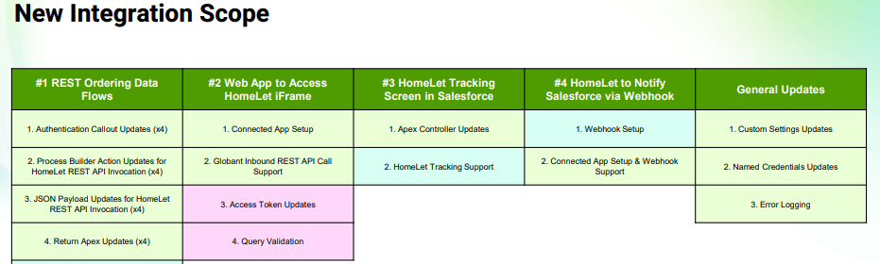

References
- Van Mildert Integration Specification.pdf (2020-04-03)
- Vision+ API Documentation V r1.0.pdf
- Meeting with Scott Knight and Jaic George 2023-04-13
- Meeting with Scott Knight and Jaic George 2023-04-13

Project Objectives
Engage with key stakeholders to:
- Create and prioritize the requirements backlog to determine the final scope of the solution’s first release.
- For each in-scope user story, define acceptance criteria which describe the conditions that must be satisfied for a user story to be deemed complete.
- Implement the solution using Salesforce
See Project Delivery Methodology for details of how the solution will be delivered and tested.

Responsibilities

Open Box will:
- Complete the Project Objectives detailed above.
- Provide prompt review and feedback to questions and comments from .
- Make the necessary personnel available during the project as and when required, ensuring no delays occur through all phases, per scheduling set forth in Cost and Resourcing and in full compliance with the Agreement.
- Provide project deliverables on-schedule and timely responding to feedback in accordance with the mutually agreed upon acceptance procedure.

are responsible for:
- Purchasing the required licenses from Salesforce.
- Making the necessary personnel available during the project as and when required, providing timely input through the various phases. Timing commitments cannot be guaranteed by Open Box if personnel are not made available to the project.
- Signing off the mutually agreed upon Statement of Work.
- Providing prompt review, feedback and sign-off of project deliverables in accordance with the mutually agreed upon acceptance procedure.
- Involving the correct level of stakeholder representation during the various phases of the project.
- Providing all available supporting documentation as requested from time to time by Open Box.
- Ensuring there are no other projects planned or in operation that may hinder this project.

Project Administration
- Resources will be contactable on email and available for meetings via conference or video calls.
- Project resources will be available Monday to Friday 9am – 6pm South African Time (GMT +02:00).
- A defined escalation path will be provided to the agreed project manager should urgent assistance be required outside of these times.
- Open Box will provide a regular report to the agreed project manager which includes:
  - Overall project health.
  - Project risks.
  - Project milestones and timeline.
  - All other details required by throughout the project, which will include, at a minimum, all details sufficient for to assess project progress, timeliness under the agreed schedule, and fulfillment of the specifications necessary under each user story.

Exclusions & Limitations
The following is not included in the cost or scope of this project (these may be addressed as future projects as necessary).
- Data migration is limited to a subset of data required to support the use of the solution going forward, as identified in the requirements backlog created during the Analysis phase. It does not include the migration of all historical school performance data.
- Travel or on-site resources as all work will be performed remotely.
- End-user training or delivery of testing materials. Open Box Software will follow a “train the trainer” methodology where designated users are trained during the Sprint UAT sessions, PAT users are responsible for training other end users.
- Change management and adoption will be the responsibility of .
- Testing of the web solution using:
  - Any browser other than Chrome.
  - Mobile browsers or devices.
- Only the browsers detailed within Salesforce Help will be supported by the web solution.

Cost and Resourcing

Salesforce Licese Fees

Indicative Costing

Salesforce is a SaaS solution (priced in USD) priced per user per month, normally paid annually. will purchase licenses directly from Salesforce and may be able to negotiate more favourable pricing depending on license numbers and length of contract. Open Box Software will assist with recommendations on license types and volumes, but the final pricing and contract conditions will be agreed directly between Salesforce and .
The indicative costing below is based on the user numbers as understood from discussions with the team. The costing is discounted because of ’s non profit status – for example the list price of Sales Cloud licenses is $150/user/month vs. $105 below. Further discounts may be possible pending negotiations with Salesforce.

License Type | Description | Monthly cost (USD/user/month) | Qty | Yearly Cost (USD)
Sales Cloud License | Full license used for admin and access to Sales Cloud for fundraising activities | $105 | 4 | $5,040
Lightning Platform Starter | Reduced functionality license used to access Education Cloud data (i.e. internal users who require access to everything except fundraising functionality) | $17.5 | 6 | $1,260
Customer Community Plus | License for external users to view and enter data via the "community cloud" portal | $9.75 | 40 | $4,680
 |  | TOTAL PER YEAR (USD) |  | $10,980

Note: the above pricing is indicative only. Final pricing will be agreed contractually between Salesforce and and is specifically excluded from this SOW.

Implementation Costs

Open Box Software will be responsible for setting up the Salesforce org and customising it to ’s requirements. The key activities involved in this implementation are detailed as below
- Analysis
  - Requirements gathering, backlog creation
  - High level solution design
- Build
  - Customisation (adjusting the data model, adding workflows, page layouts etc.)
  - Data migration (i.e. loading historical data)
  - Training, testing and deployment
- Go Live Support
  - Technical support for issues raised within the first 2 weeks after go-live
Assuming implementation of the “Must Have” and “Should Have” requirements captured within the backlog during the Analysis phase, the first release of the solution is estimated to require the projected resource allocations:

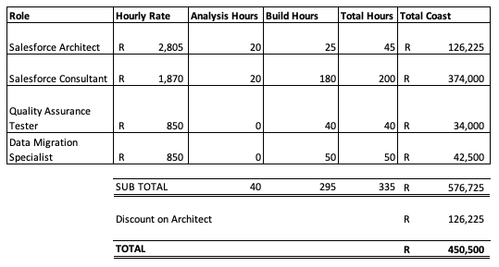

- The cost of the Salesforce Architect will be waived by Open Box Software for this particular project
- The consultancy and all development work will be provided remotely.
- Costs exclude travel or onsite analysis.
- All amounts are in ZAR (R) and excludes any sales taxes, if applicable.
- This quotation is valid for 30 days.
- Quoted amounts do not include:
  - Salesforce license fees as outlined in 3.1 Salesforce Licese Fees
  - Any other third-party costs, license fees, subscriptions or services.
  - Hardware and infrastructure.
  - Support and maintenance beyond the go-live support detailed within Implementation.
  - Travel and subsistence.
- The project timeline is shown below, showing an anticipated 8 week project. Actual go live date will depend on start date of “Week 1” to be agreed between and Open Box Software.
- Open Box will invoice each month for an amount based on percentage complete.

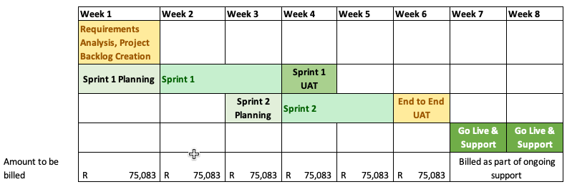
Figure 2 Project Timeline by Week

6 month support transition plan

Open Box Software will provide 20 hours / month support for a period of six months. During this time, the support hours will be used to handle basic Salesforce support and administration tasks, working closely with the team. This is to ensure knowledge transfer and upskilling so that the team are able to take over the support of their Salesforce org at the end of the six month period.
Should Open Box support be required beyond the six month period this would continue on a month-to-month basis.

Cost
- The 2023 Salesforce Administrator Support rate is ZAR 850/hour, i.e. Open Box Software will bill an amount of ZAR 17,000/month for 20 hours/month
- Support hours will be billed monthly in arrears
- Unused hours at the end of the month will not roll over into the next month
- When more advanced Salesforce development skills are required, Open Box will assist on a time and materials (T&M) basis at a rate of ZAR 1,870/hour. All work of this nature will first be estimated by Open Box Software and approved by before any hours are worked.

Project Delivery Methodology
Open Box will develop the solution for using a SCRUM Agile methodology. Development of features will be done via sprints, where the features delivered for each sprint are reviewed and tested by .

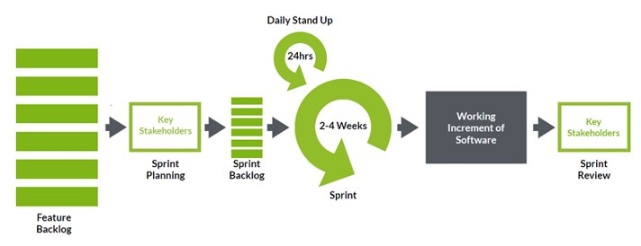
Figure 3: High-Level Iteration Process

Requirement Analysis & Project Backlog Creation
- Open Box will assess the key service requirements in consultation with . These requirements will be refined and documented in more detail by Open Box as user stories that are approved by , collectively forming the project backlog.
- will prioritize the user stories for each sprint based on business value vs. technical effort, in reliance on the input provided by Open Box as to the Open Box resources and hours necessary to complete each user story.
- The user stories to be delivered will be reviewed, acceptance criteria will be documented and then prioritized by and Open Box. All deliverables are subject to acceptance by .

Sprint planning
- User stories from the backlog will be prioritized based on business value versus technical effort, then assigned to the sprint backlog.
- Sprint backlogs will be curated by Open Box, with input from , such that the stories allocated to each backlog can feasibly be delivered, unit tested and QA tested during the sprint in accordance with the deliverables schedule and efficient delivery of ’s desired functionality and technical requirements.

Sprint
- Open Box will develop the functionality as specified in each of the approved user stories in the sprint backlog.
- Daily stand-up calls will be held to report on progress and blockers, the product owner is expected to participate in this call to provide feedback on any functional questions that may arise.
- Open Box will be responsible for unit testing and QA testing of all functionality delivered during the sprint.
- On completion of the sprint, Open Box will demo all functionality delivered during the sprint.

Sprint UAT
- Designated users will be given access to a dedicated UAT sandbox in order to test the functionality delivered during the sprint.
- will be expected to sign off on each user story, using the agreed acceptance criteria to determine whether the feature has been successfully delivered.
- Issues logged during the UAT will be classified by as bugs or enhancements based on the user story and acceptance criteria. Bugs will be fixed during the sprint UAT or a subsequent sprint, whereas enhancements will be added to the project backlog and reviewed during subsequent sprint prioritization sessions.

End-to-End UAT
- Designated users will be given access to a dedicated UAT sandbox to test the functionality end-to-end and ensure that the overall business process delivered by the application is functioning correctly.
- Issues logged during the end-to-end UAT will be classified by as bugs or enhancements based on the user story and acceptance criteria. Bugs will be fixed during the UAT prior to production deployment. Any significant changes or new requirements that are identified will be documented and added to the service backlog for future development.
- The end-to-end UAT will take place over 5 business days. The UAT will considered to be passed if all user stories have been signed off by to be meeting the agreed acceptance criteria.

Go-Live and Support
- On successful completion of the end-to-end UAT, Open Box will deploy the configuration to the production org.
- The Open Box project team will provide post go-live support for 2 weeks (10 working days) following the production deployment. Following the post go-live support period, bugs and/or enhancements will be handled under the ongoing support process outlined in the ongoing support section above.
- Issues logged after go-live that are not classified as bugs based on the user story and acceptance criteria will be fixed or addressed by Open Box on a time and materials basis pursuant to a Change Order. Any significant changes or new requirements that are identified will be documented and added to the service backlog for future development upon mutual agreement by Open Box and .

Acceptance
The parties hereto, each acting under due and proper authority, have executed this Agreement as of the day, month and year first written below.
For and on behalf of  Open Box Software |  |  | For and on behalf of
Signature: |  |  | Signature:
Name: | Sam Duncan |  | Name:
Position: | Director of Salesforce |  | Position:
Date: |  |  | Date:

